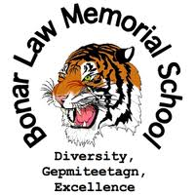

**Supply List for Grades 9 & 10 (2025-26)**

* Dividers (10)
* 10 pencils
* Pencil crayons
* 1 glue stick
* 2 erasers
* 2 highlighters
* 5 1” binders
* 3 x 200 pages of looseleaf
* 1 pack of 50 pages of graph paper
* French\English dictionary
* 4 blue pens
* 2 red pens
* **Scientific calculator**
* **Geometry set (Grade 10)**
* Ruler
* Scissors
* Becherelle **( French Immersion students only)**
* 2 correction fluids (white out)
* 8 duotangs
* Gym clothes
* Sneakers
* Sunscreen (Phys. Ed – outdoor activities)
* Towel (Phys. Ed)
* Wired headset or earbuds (not Bluetooth)
* 2 boxes of Kleenex for homeroom teacher

BLMS student fee is $40 for one child or $60 for two or more children.